Science - cress heads
On Friday last week, we made some cress heads. If you made one at school we would love to see what they look like now.
I worked with my children at home to make cress heads too! We couldn’t print pictures like we did in school so we made our own funny faces!
We laid a paper towel in the bottom of the cup and them some wet cotton wool. We sprinkled lots of seeds on top of the cotton wool and pushed them down a little. We placed the cups on the windowsill where there was plenty of light.
The pictures below show how the cress looked on Day 5. The cress is growing fast and getting very long. We are going to give it a little wash and make egg and cress sandwiches.
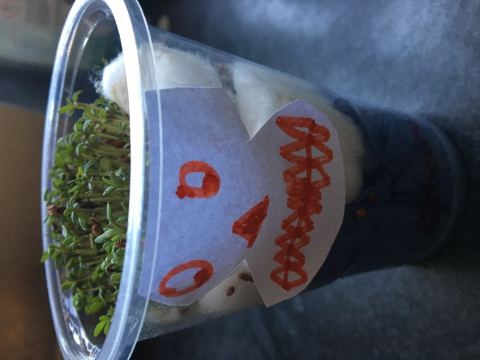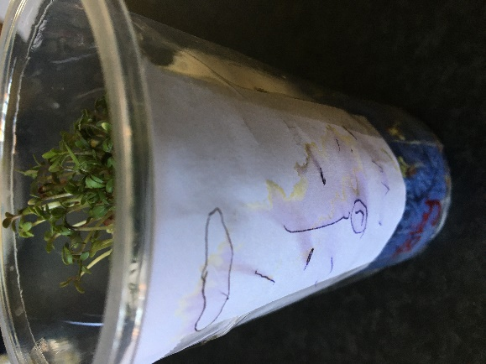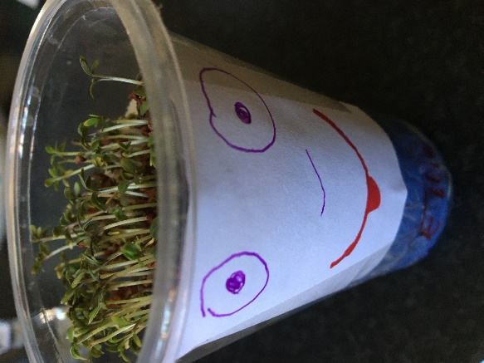

See if you can write a seed diary about your cress head or try planting some seeds at home and record what happens every few days. This links to our science topic in school.
From Mrs Martin & the Year 2 team
homelearning@st-edmunds.suffolk.sch.uk

