St Edmund’s & St Joseph’s Catholic Primary Schools
Week commencing: 30th March 2020 Class: Abraham
Learning Characteristic - Motivated
Below are some suggestions for learning that your child can do at home this week. We understand that the situation is unprecedented, however we do recommend that the children stay in touch with their learning using the ideas given below. You can help keep your child in contact with the school via the email link shown at the end of this message. Your child may want to share their achievements with their teacher by photographing or scanning it and sending it via email. A teacher will reply with a comment about the work shared.
Please email any completed activities/work to: homelearning@st-edmunds.suffolk.sch.uk

Subject/ Theme | Learning ideas and activities
English | Aim to read at least 1 book a week and take the Accelerated Reader Quiz for it.  This week’s spellings – I will put the new set of spellings on Spelling Shed from Monday for you to learn. Those of you who learn 5 can ask a parent to choose 5 for you to learn. The two children who have spellings off the Year 1 and 2 word list, please could you pick 5 a week from the list to learn.  See if you can find some examples of these poems to read. Then have a go at writing your own if you like!  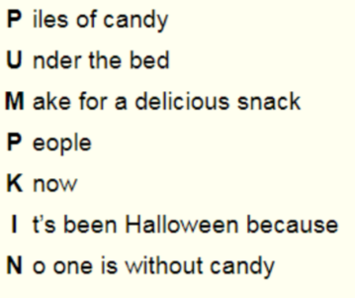  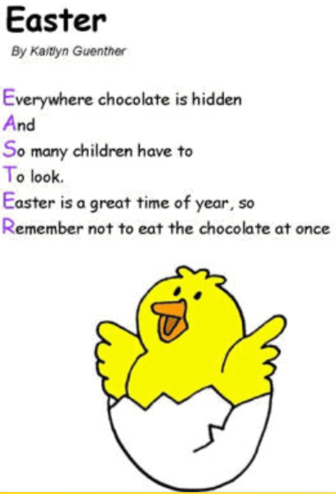  ACROSTIC POEMS – The first letter of each line spells a word – that is the subject/theme of the poem. We need to read it vertically. Each line does not need to rhyme and can be a long/short as the writer chooses. For example -  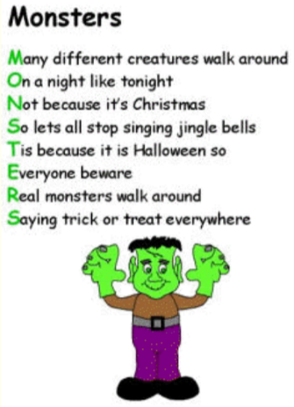  HAIKU POEMS - a Haiku is a traditional Japanese form of poetry that has no title. It also has a set number of syllables in each line (5, 7, 5) and they are usually written about nature. Haiku poems don’t usually rhyme.  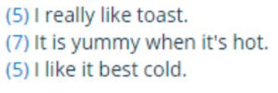  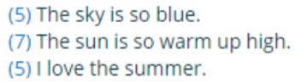  SHAPE POEMS - A shape poem is a poem that is shaped like the thing it describes. The shape adds to the meaning of the poem. To write a shape poem, it helps to start by writing down all the words that come to mind about the chosen topic. These words can then be used in the poem.  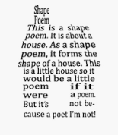  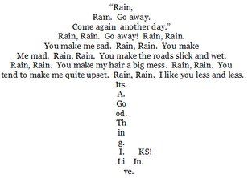  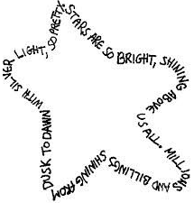  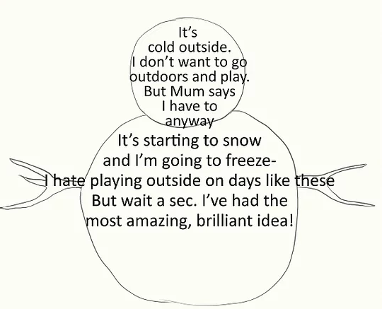
Maths | https://whiterosemaths.com/homelearning/year-4/  This gives you a Maths lesson for each day this week - it's manageable and you can check to see how you're doing.  TT Rock Stars: Please do a Sound Check each day as well as all the other fun and games TT Rock Stars. Keep aiming to break your own records. Keep a record of your scores to check how you are doing.  Don’t forget to do this week’s Mathletics learning tasks. Make sure you have caught up with all the Mathletics tasks that have been assigned this year.
Science, History or Geography | Geography  We had started our topic on The Sunshine State (Florida) and we had started looking at the Magic Kingdom.  For this week I’d like you to write down 5 facts about Florida and 5 facts about The Magic Kingdom. This can include pictures and drawings.  You could also show these facts in a poster.
Physical Education | https://www.youtube.com/watch?v=Rz0go1pTda8  Work out with Joe Wicks – he does a new one every day.  If you go outside remember that you are only allowed out of your house to exercise once a day with someone else you live with and you must keep at least 2m away from anyone else. Please do not go to a park where you will be close to other people.
Arty crafty ideas | Below is a picture of a 30 day art challenge which is similar to the 30 day Lego challenge. You don’t have to do them in order and you can choose the ones you like the sound of.  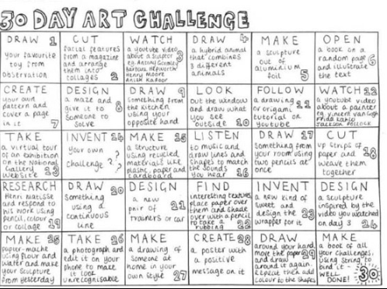
French | Investigate French landmarks and make a fact file about one of them. Create a 3-D model of it using recycled materials/toothpicks etc...

