St Edmund’s & St Joseph’s Catholic Primary Schools
Week commencing: 6th April 2020 Year group: Early Years
Below are some suggestions for learning that your child can do at home this week. We understand that the situation is unprecedented, however we do recommend that the children stay in touch with their learning using the ideas given below. You can help keep your child in contact with the school via the email link shown at the end of this message. Your child may want to share their achievements with their teacher by photographing or scanning it and sending it via email. A teacher will reply with a comment about the work shared.
Please email any completed activities/work to: homelearning@st-edmunds.suffolk.sch.uk
You can also send us your home learning via Tapestry, we love to see what you have been doing!

Subject/ Theme | Learning ideas and activities
Literacy | Can you make an Easter card for a family member of loved one?  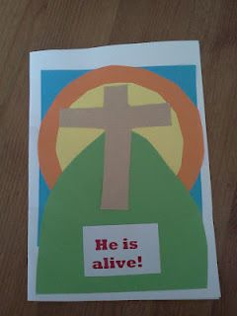  Practice writing the words to and from.  Write an Easter message to wish your family a Happy Easter. Can you copy the address and write it on the envelope?  Useful website for story telling:  https://www.booktrust.org.uk/books-and-reading/have-some-fun/
Maths | 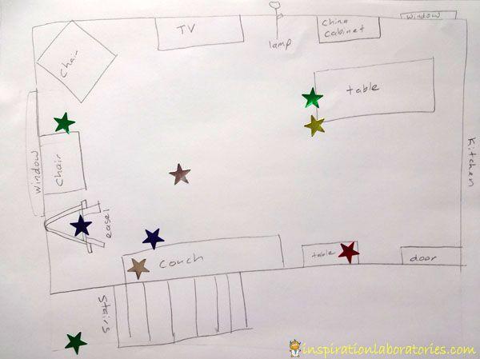  Draw a map of your garden and design an Easter egg/bunny hunt with clues. These could be picture or word clues. Can you number your clues? How many steps can you count to each clue?  Can you solve these number problems? If there are 5 Easter eggs in the basket and 2 get eaten, how many are left? Draw a picture to help you solve the problem or write the answer as a number sentence 5-2=3
Understanding the world (UW) | Can you make an Easter story book, with pictures and simple sentences to explain the Easter story. Twinkle has some good free resources to help with this.  There also some great activities on this website www.funlearningforkids.com
Physical development (PD) | Cut around a cube template to make an Easter basket or make one using an old cardboard box. Decorate the box/basket with spring and Easter pictures – use glue and folding techniques to assemble the box. Fill with Easter treats!  Easter Yoga - https://www.dailymotion.com/video/x68w12q Follow this story and try some yoga!  Make your Easter Egg hunt into an obstacle course.
Art and design ( EAD) | Can you make an Easter Garden that helps to represent the true meaning of Easter?  Either in a tray, box, lid, container etc... you could use natural materials e.g. grass, moss, stones, mud, sticks for the crosses etc... or things like tissue paper, clay, papier mache to represent the different parts of the Easter story. Below are some ideas of how you could do this with your child.  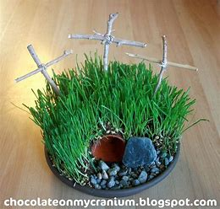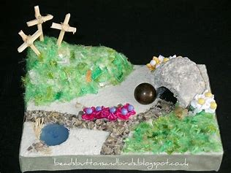  Send us a picture on Tapestry of your Easter garden. We would love to see it!

