St Edmund’s & St Joseph’s Catholic Primary Schools
Week commencing: 13th April 2020 Year group: Early Years
Below are some suggestions for learning that your child can do at home this week. We understand that the situation is unprecedented, however we do recommend that the children stay in touch with their learning using the ideas given below. You can help keep your child in contact with the school via the email link shown at the end of this message. Your child may want to share their achievements with their teacher by photographing or scanning it and sending it via email. A teacher will reply with a comment about the work shared.
Please email any completed activities/work to: homelearning@st-edmunds.suffolk.sch.uk
You can also send us your home learning via Tapestry, we love to see what you have been doing!

Subject/ Theme | Learning ideas and activities
Literacy | 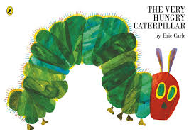  This week we will be focussing on the story of The Very Hungry Caterpillar by Eric Carle.  If you don’t have the book you can find the story on you tube.  In the story the hungry caterpillar like to eat lots of different food. What is your favourite food? Can you draw a picture and write a simple sentence about your favourite food?  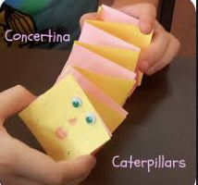  Can you practice singing the tricky word song we use in class?  Phase 2: https://www.youtube.com/watch?v=TvMyssfAUx0  Phase 3: https://www.youtube.com/watch?v=R087lYrRpgY  You could then make a tricky word caterpillar book:
Maths | In the story the caterpillar eats different food each day. Can you remember the days of the week? Write them out and put them in order. Sing a days of the week song.  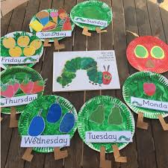  The caterpillar eats lot of different amounts of fruit. Can you double the amount of fruit to find the total and record as a number sentence? 5+5=10 or double 5 is 10
Understanding the world (UW) | 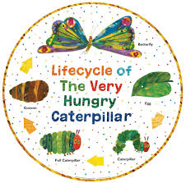  In the story the caterpillar turns into a butterfly. Can you make a picture or collage to show the life cycle of the butterfly?  Can you research what other things turn into?  What does a tadpole turn into?  Can you create its life cycle?
Physical development (PD) | https://www.youtube.com/watch?v=YnuOeG2EpVk  Try this yoga story of The Very Hungry Caterpillar!  Can you make some playdough and then use it to make a caterpillar?  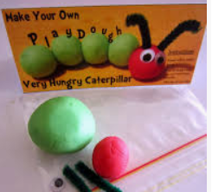  Play dough simple recipe:  - 1 cup of flour.  - 1/4 cup of salt.  - 3/4 cup of hot water.  - 1 tablespoon of vegetable oil.  - Food colouring.
Art and design ( EAD) | 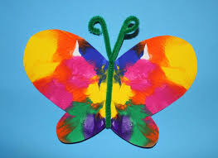  The caterpillar turns into a beautiful butterfly. Can you paint half of a butterfly and fold it over to make the other half so that it is symmetrical?
 | Good luck with this weeks home learning, please send photos on Tapestry so we can see how you are getting on and keep up the amazing job you are doing. From all the Early Years Team! We miss you all!

