St Edmund’s & St Joseph’s Catholic Primary Schools
Week commencing: 20th April 2020 Year group: Early Years
Below are some suggestions for learning that your child can do at home this week. We understand that the situation is unprecedented, however we do recommend that the children stay in touch with their learning using the ideas given below. You can help keep your child in contact with the school via the email link shown at the end of this message. Your child may want to share their achievements with their teacher by photographing or scanning it and sending it via email. A teacher will reply with a comment about the work shared.
Please email any completed activities/work to: homelearning@st-edmunds.suffolk.sch.uk
You can also send us your home learning via Tapestry, we love to see what you have been doing!

Subject/ Theme | Learning ideas and activities
Literacy | 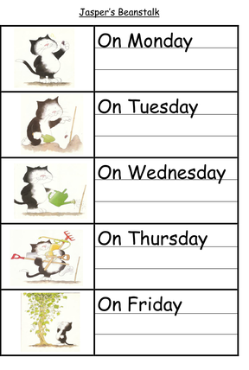  This week we will be focusing on the story of Jasper’s Beanstalk by Nick Butterworth  If you don’t have the book you can find the story on you tube, or watch our own story telling on tapestry.  Jasper does something different each day for his bean. Can you write a sentence for each day of the week and draw a picture to go with it?  Can you practice singing the tricky word song we use in class?  Phase 2: https://www.youtube.com/watch?v=TvMyssfAUx0  Phase 3: https://www.youtube.com/watch?v=R087lYrRpgY  Could you have a go at writing your tricky words on the leaves of a beanstalk?
Maths | 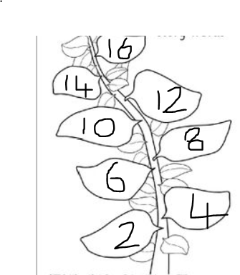  Draw a beanstalk and make leaves to go on your beanstalk. Label the leaves in twos, fives or tens and put them in order on your beanstalk. What number did you get do?
Understanding the world (UW) | If you still have your beanstalk, how tall is it? Can you measure it using your hands? How many hands tall is it? Can you remember what a plant needs to grow? What do you need to keep you healthy and to help you grow?  Watch this time lapse video of a bean growing https://www.youtube.com/watch?v=w77zPAtVTuI
Communication and Language (CL) | Can you make up your own story about Jasper? What would happen if he climbed his beanstalk? What would he find at the top of the beanstalk? Can you retell your story to teddy bear or doll starting with ‘Once upon a time…’
Personal, Social and Emotional Development (PSED) |   Talk about how Jasper felt at different times during the story. Make a feelings clock and talk about how you feel at different times throughout the day.
Physical development (PD) | Can you play the bean game? Can you bounce like a jumping bean? Can you wobble like a jellybean? Can stretch up tall like a string bean? Can you stretch your arms and legs wide like a broad bean? Can you run around like a runner bean?  https://www.youtube.com/watch?v=Hfu35LOof1o
Art and design ( EAD) | 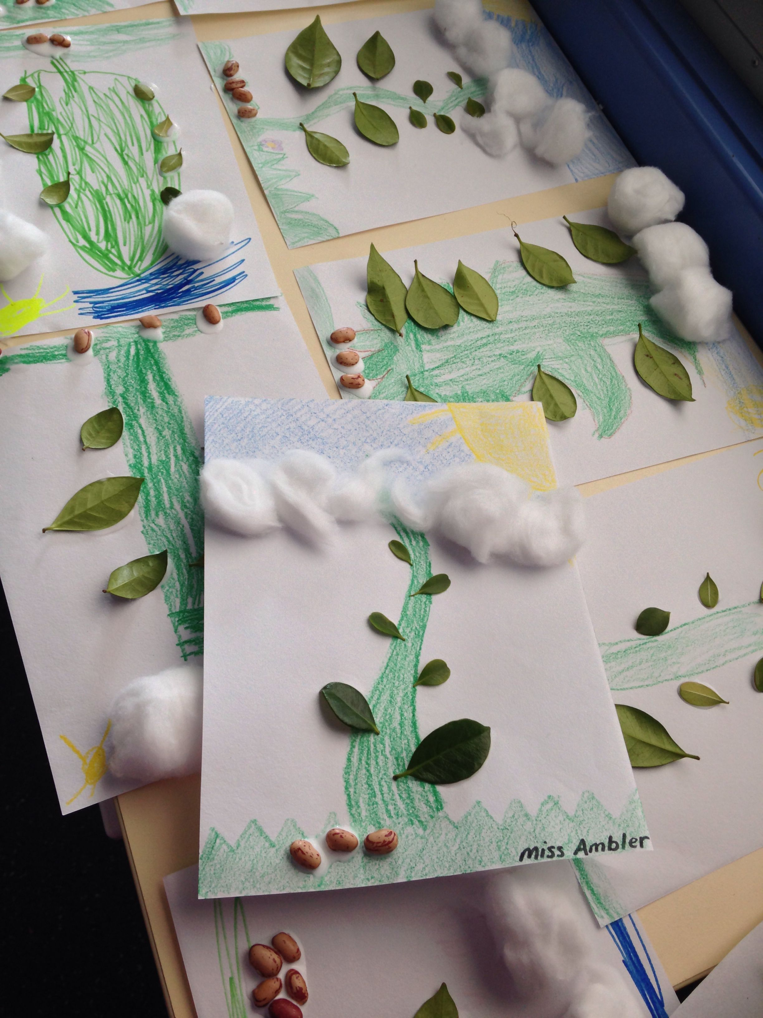  Draw a picture of Jasper and the beanstalk. What do you think is at the top of the beanstalk? Can you draw it? Use your imagination!  Can you use some real leaves to make a picture of the beanstalk?
Good luck with this weeks home learning, please send photos on Tapestry so we can see how you are getting on and keep up the amazing job you are doing. From all the Early Years Team! We miss you all!

