St Edmund’s & St Joseph’s Catholic Primary Schools
Week commencing: 27th April 2020 Year group: Early Years
Below are some suggestions for learning that your child can do at home this week. We understand that the situation is unprecedented, however we do recommend that the children stay in touch with their learning using the ideas given below. You can help keep your child in contact with the school via the email link shown at the end of this message. Your child may want to share their achievements with their teacher by photographing or scanning it and sending it via email. A teacher will reply with a comment about the work shared.
Please email any completed activities/work to: homelearning@st-edmunds.suffolk.sch.uk
You can also send us your home learning via Tapestry, we love to see what you have been doing!

Subject/ Theme | Learning ideas and activities
Literacy | Please enjoy the story of The Little Red Hen (see attached) or you may have your own version to read together.  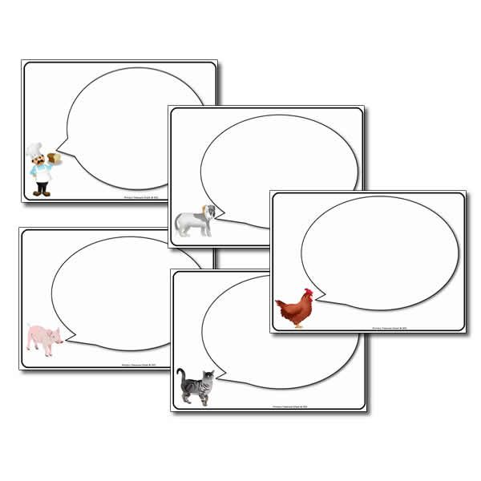  Can you make a story map for the story? Can you write some speech bubbles for what the characters say in the story? Can you write ‘Not I’ for when the characters don’t want to help?  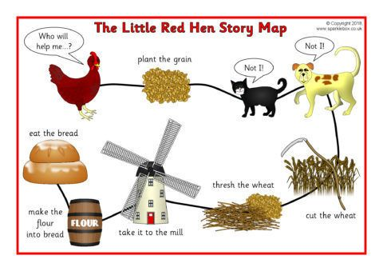
Maths | Can you put the events in the story in the right order? Talk about the language of ordinal numbers eg first, second, third, fourth  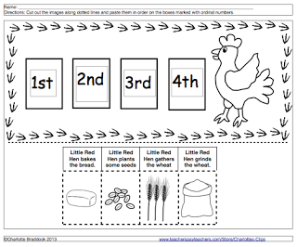
Understanding the world (UW) | Can you research all about hens, where do they live, what do they eat, how do we look after them? Make an information page all about hens. Draw a picture of a hen and label the different parts.  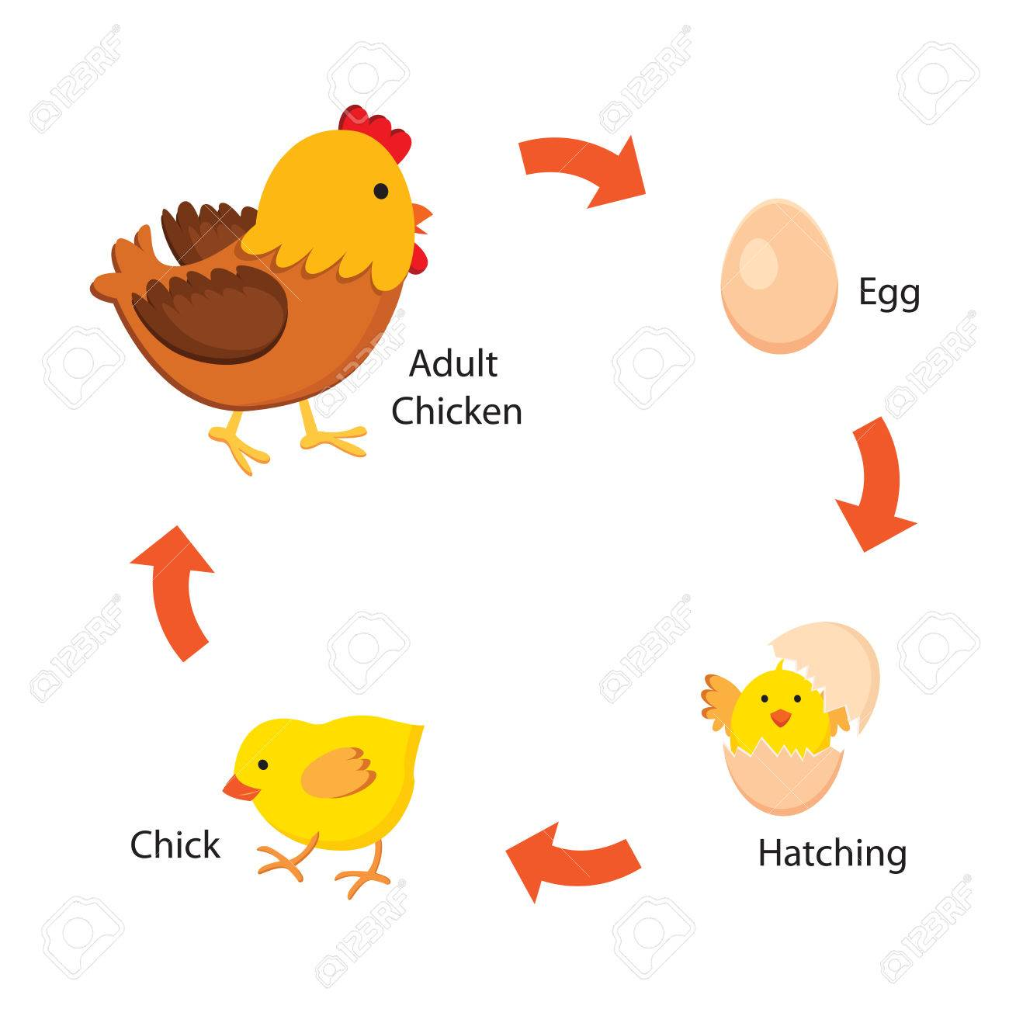  Maybe you can draw the life cycle of a hen?
Physical development (PD) |   If you have the ingredients can you follow a recipe to make some simple bread rolls? Talk about flour and make some bread rolls together. Make and knead the dough, then shape them into rolls and bake them in the oven.  Watch this you tube cartoon about how bread is made.  https://www.youtube.com/watch?v=glWpjy2qpPk
Art and design ( EAD) | 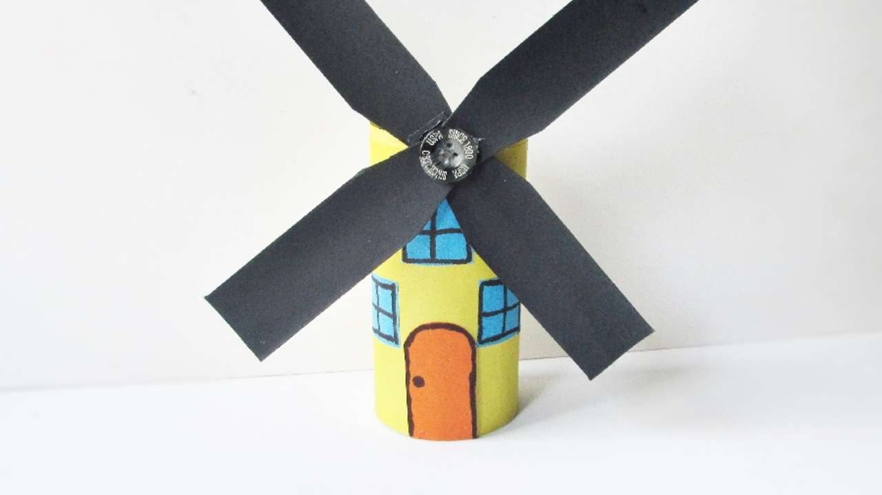  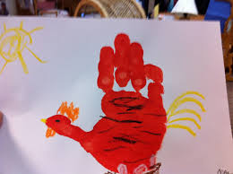  Can you make a handprint little red hen or a model windmill using cardboard boxes?
Communication and Language (C&L) | 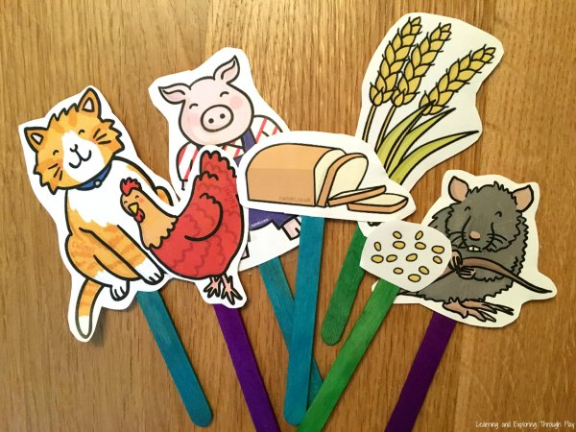  Make some stick puppets and use them to retell the story.
Personal, Social and Emotional (PSED) | 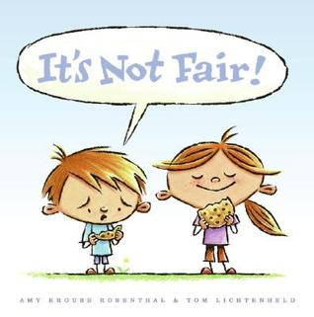  Would you help the little red hen if she asked? Discuss the answer ‘Yes I would’ or No I wouldn’t’ Talk about what it means to be fair? How does the little red hen feel when no one helps? Should everyone get some of the bread or not?  Talk about how we should help each other out, then make a helping hand by drawing around your hand and decorating, next write on the hand what you have decided to do to help someone.
 | Good luck with this weeks home learning, please send photos on Tapestry so we can see how you are getting on and keep up the amazing job you are doing. From all the Early Years Team! We miss you all!

