St Edmund’s & St Joseph’s Catholic Primary Schools
Week commencing: 4th May 2020 Year group: Early Years
Below are some suggestions for learning that your child can do at home this week. We understand that the situation is unprecedented, however we do recommend that the children stay in touch with their learning using the ideas given below. You can help keep your child in contact with the school via the email link shown at the end of this message. Your child may want to share their achievements with their teacher by photographing or scanning it and sending it via email. A teacher will reply with a comment about the work shared.
Please email any completed activities/work to: homelearning@st-edmunds.suffolk.sch.uk
You can also send us your home learning via Tapestry, we love to see what you have been doing!

Subject/ Theme | Learning ideas and activities
Literacy | Please enjoy the story of Farmer Duck (see attached) or you may have your own version to red together.  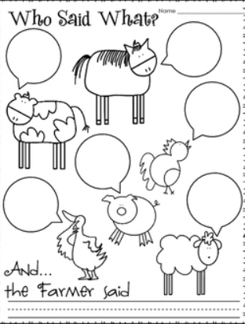  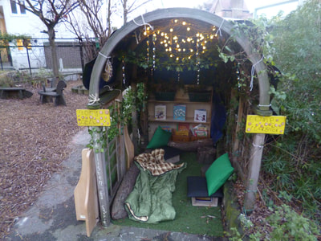  Can you create a reading den in your garden or in your bedroom? You could use blankets and cushions, covered with sheets or tarpaulin. Have a selection of favourite books to read and share together. Can you decorate your den with tricky words, or maybe have some passwords to read to get into your den?  Can you write about your favourite farm animal? Encourage your child to write about what their animal looks like, what they eat, what sound they make or what the baby animals are called.
Maths | Can you hide a farm animal in your house or in the garden? Encourage your child to use positional language to describe where it is hiding, such as ‘under the slide’ or ‘behind the tree’.  Can you solve this number problem? There are 10 sheep in a field, half of them need to go into another field. Can you draw a picture to solve this problem and then write what half of 10 is? Can you solve other halving problems?
Understanding the world (UW) | 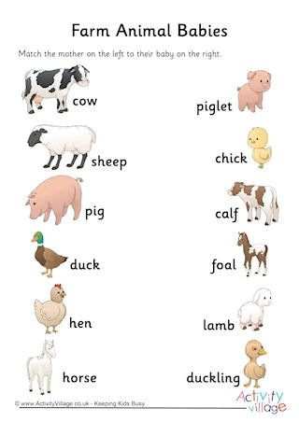  Can you find out about baby animals? What is a baby horse called? Can you match the baby to the mother?
Physical development (PD) | Explore different ways of moving to represent different farm animals? They could roll in mud to represent pigs, peck the ground to represent chickens, gallop like horses, eat grass like a cow or gambol like a lamb?
Art and design ( EAD) | Using any junk-modelling materials can you create your own farm animals, farm buildings or tractors?  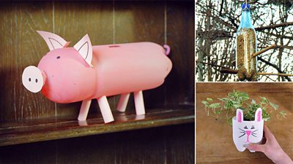  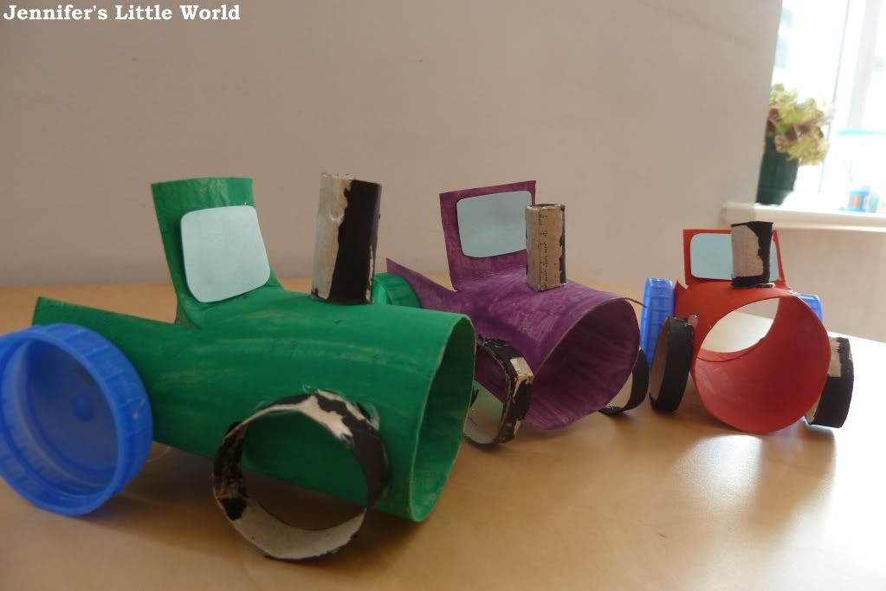
Communication and Language (C&L) | Sing the song Old McDonald had a farm. Add some musical instruments or make some from junk modelling and perform your song.  Play the game…. I went to the farm and I saw… Each player says something they might see on a farm and the next person has to add another item to the list and say what the previous people saw too!!
Personal, Social and Emotional (PSED) | How do you think the duck was feeling? What work did the farmer make the duck do? The animals in the story were good friends to the duck.  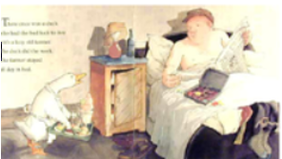  Talk to the children about how it is important to be a good friend. Draw a picture of a good friend.
 | Good luck with this weeks home learning, please send photos on Tapestry so we can see how you are getting on and keep up the amazing job you are doing. From all the Early Years Team! We miss you all!

