Year 4 Country Fact File

Choose a country and complete as many of the tasks as you wish to make a Country fact file. It can be any country in the world; one you have visited or would like to visit. It could even be somewhere we have studied and you would like to know more about.
For example: Canada
Japan
New Zealand
France India Norway
Brazil

This is YOUR project – You can complete the activities any way you like. PowerPoint, Word document, hand written booklet or poster. Be creative and remember to use your best presentation.

Useful websites to start off your research:

https://www.factmonster.com/world/countries

https://thefactfile.org/category/countries/

http://www.sciencekids.co.nz/sciencefacts/countries.html

https://www.3dgeography.co.uk/

Locating your country

Use the internet to locate your country on a world map. Print one out if you can.

Describing location.
In geography you can use several things to give a location.

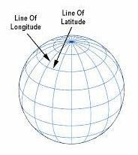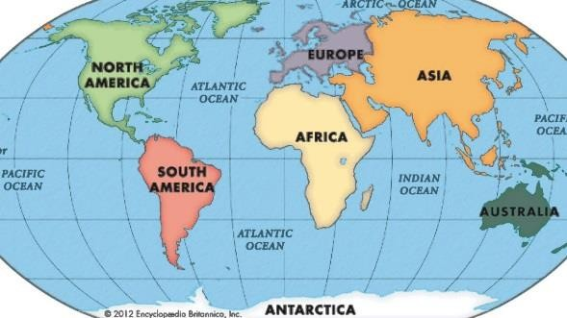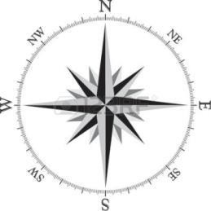

Compass latitude and Continent/countries direction longitude

Describe the location of your country in at least two sentences. Use the sentence starters below to help:

It is located in the continent of …….. It is close to the countries of………… It is near to……..
It is situated………..

People and Culture
Complete the following sentences: The capital city is called…
The currency (money) is…
Food the nation is known for…
The religion practiced the most…
This country is known for the following sport….. Find images of the following:
An average house Traditional dress Famous people
Important buildings or monuments

Find and draw the country’s flag.

Challenge
Research why the flag contains the colours it has and the importance
of any of the images it has.

Can you find 5-10 interesting facts about your chosen country

