Happy Reading!

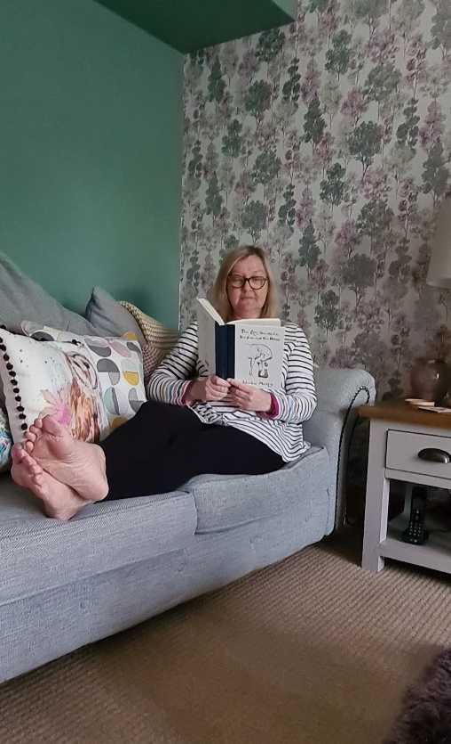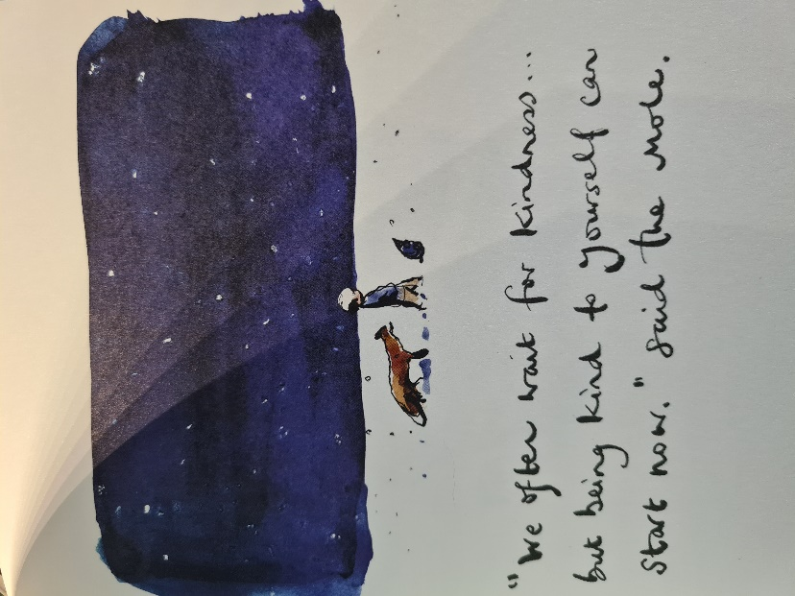

Hi children,
I thought I would share a picture of me reading one of my favourite books. Each day I find time to read for 30 minutes and today I chose ‘The Boy, the Mole, the Fox and the Horse’ by Charlie Mackesy.
It is a story about love, friendship and kindness. It explains the many mixed feelings a youngster can feel about the world around them and about how everyone has weaknesses and strengths. It tells you how there is sunlight after a storm and how one of the greatest things we can do is to love and be loved. It is a very moving book with fantastic illustrations.
What book have you been reading?
Maybe you could send me a picture of yourself reading and tell me a little bit about your book?
Take care and happy reading!
Love From
Mrs Soar x

