St Edmund’s & St Joseph’s Catholic Primary Schools
Week commencing: 11th May 2020 Year group: Early Years
Below are some suggestions for learning that your child can do at home this week. We understand that the situation is unprecedented, however we do recommend that the children stay in touch with their learning using the ideas given below. You can help keep your child in contact with the school via the email link shown at the end of this message. Your child may want to share their achievements with their teacher by photographing or scanning it and sending it via email. A teacher will reply with a comment about the work shared.
Please email any completed activities/work to: homelearning@st-edmunds.suffolk.sch.uk
You can also send us your home learning via Tapestry, we love to see what you have been doing!

Subject/ Theme | Learning ideas and activities
Literacy |   This week’s story is ‘The Tiger Who came to tea’ by Juliet Kerr  Can you organize a tea party for your teddy’s this week?  You could write them an invitation?  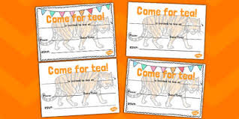
Maths | 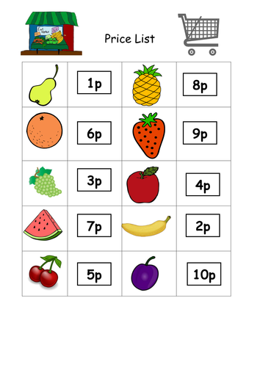  Can you write a shopping list for all the things you need for your tea party. Write how much each item will cost eg 5p 7p 10p Find the total cost for selected items on your shopping list.  Eg How much is the apple and banana?  4p+2p=6p  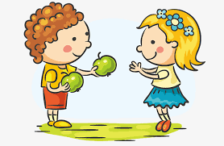  At your tea party share the food equally. How many grapes does each teddy get? How many biscuits? How many raisins?
Understanding the world (UW) | 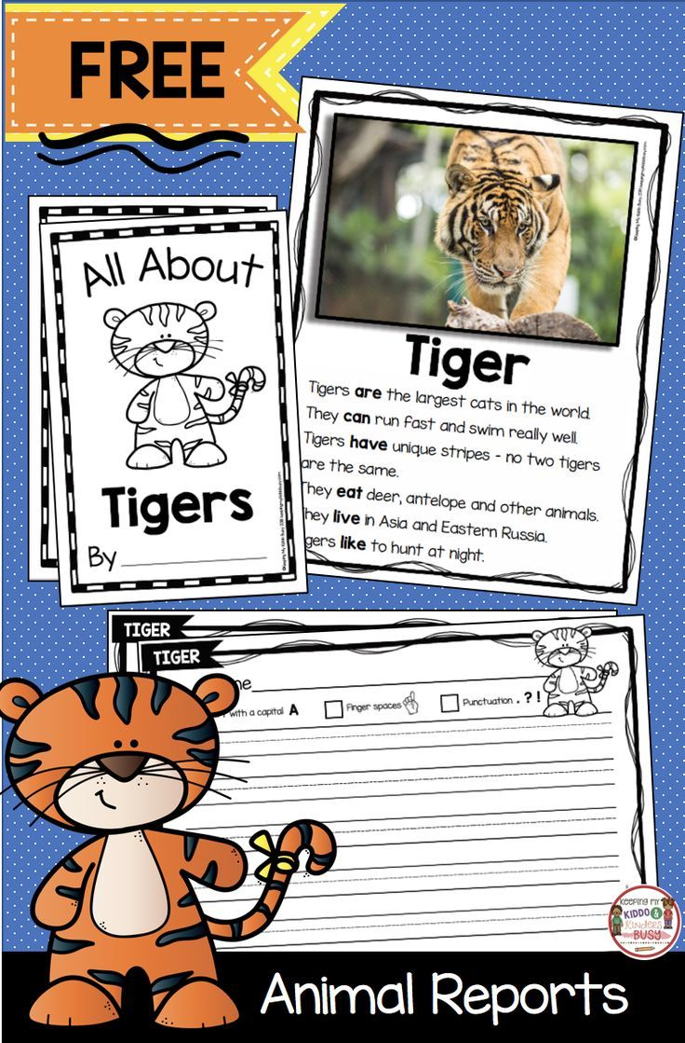  Make a nonfiction page for a book about tigers. Draw and label a picture. Write some simple facts about tigers.
Physical development (PD) |   Make some sandwiches for your tea party. Can you use a knife safely to spread the butter and cut the sandwich? Can you safely cut up some fruit for your tea party?
Art and design ( EAD) | 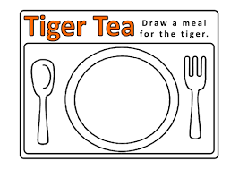  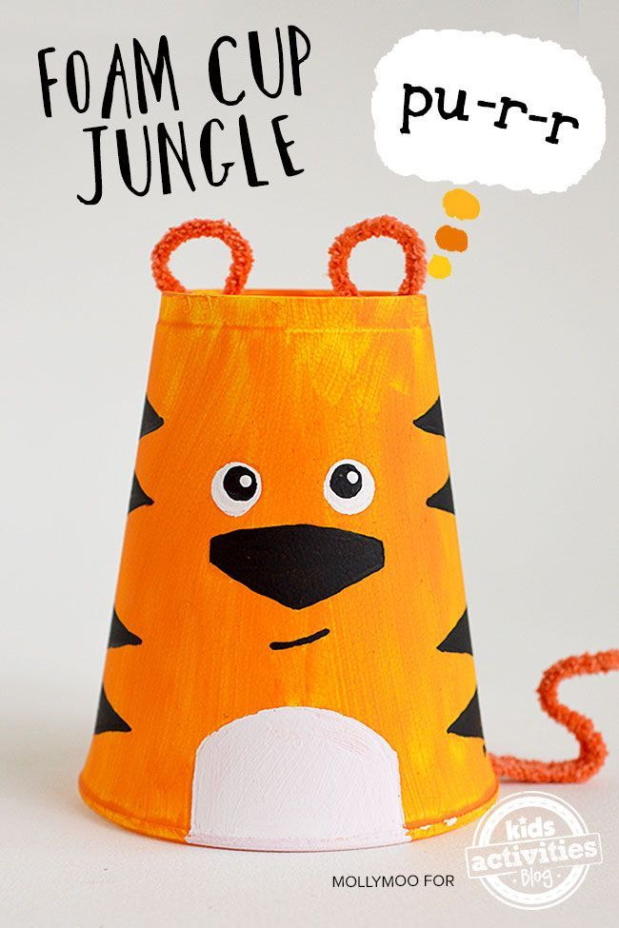  Can you draw a meal for a tiger or make a tiger out of a plastic cup?  Can you make a paper plate tiger mask?  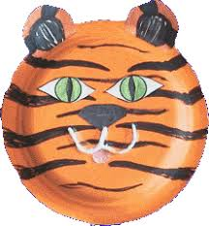
Communication and Language (C&L) | 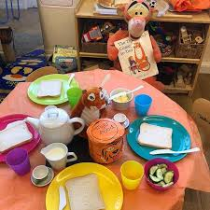  Enjoy a tea party with your teddy’s. Can you join in and sing this tiger who came to tea song?  https://www.youtube.com/watch?v=CgTHukOXhDw  Don’t forget to send us a photo of your tea party.
Personal, Social and Emotional (PSED) |   The tiger wasn't very polite when he ate all of Sophie's food. Can you think of some manners that he should need to remember when he visits someone else's house? Write a list of manners to have at your tea party.
 | Good luck with this weeks home learning, please send photos on Tapestry so we can see how you are getting on and keep up the amazing job you are doing. From all the Early Years Team! We miss you all!

