St Edmund’s & St Joseph’s Catholic Primary Schools
Week commencing: 18th May 2020 Year group: Early Years
Below are some suggestions for learning that your child can do at home this week. We understand that the situation is unprecedented, however we do recommend that the children stay in touch with their learning using the ideas given below. You can help keep your child in contact with the school via the email link shown at the end of this message. Your child may want to share their achievements with their teacher by photographing or scanning it and sending it via email. A teacher will reply with a comment about the work shared.
Please email any completed activities/work to: homelearning@st-edmunds.suffolk.sch.uk
You can also send us your home learning via Tapestry, we love to see what you have been doing!

Subject/ Theme | Learning ideas and activities
Literacy | 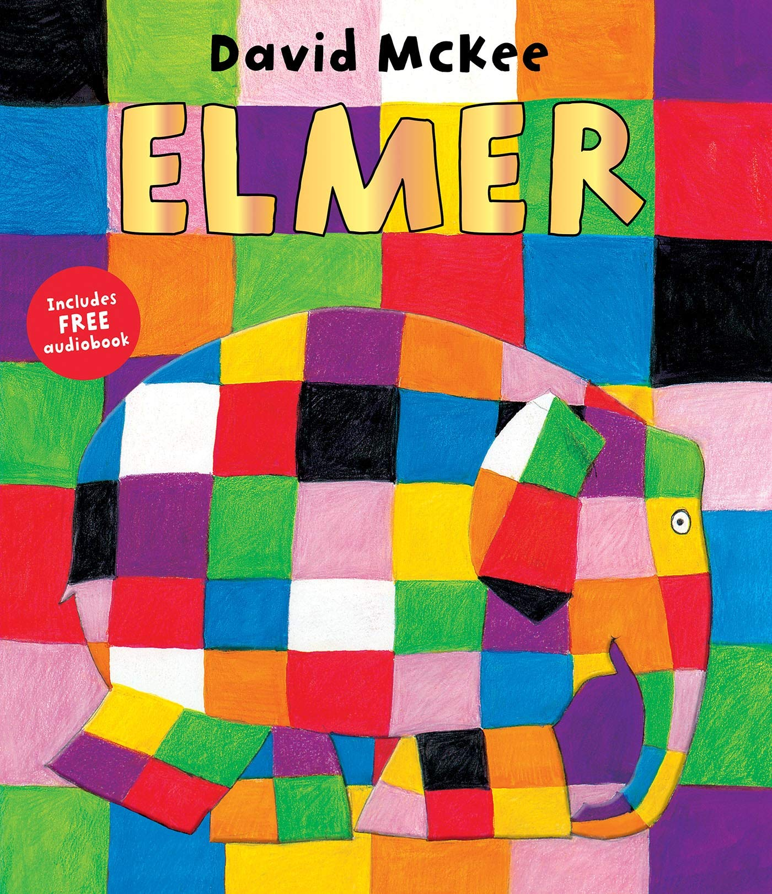  Please enjoy the story of Elmer (see attached) or you may have your own version to read together.  Lots of people like to enjoy an ‘Elmer Day!’, celebrating how unqiue and different we are! Can you create a poster encouraging the other elephants to celebrate Elmer Day? Why is it so good? What is different about Elmer?
Maths | 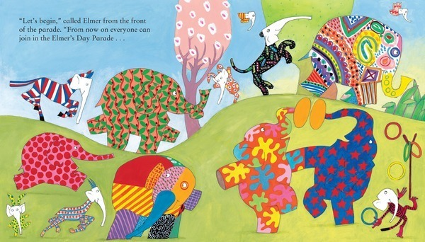  Look at the shapes and colours on the decorated elephants. Can you spot any patterns? Can you create your own pattern?  How many elephants are there in the herd? How many other animals are in the jungle? How many animals are there altogether?
Understanding the world (UW) | Can you carry out some research about different types of elephants? Can you find any facts about them? What do they eat? What are baby elephants called? Where do they live?
Physical development (PD) | 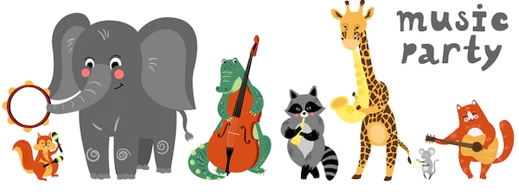  Listen to the song ‘L’Élephant’ from Saint-Saëns Carnival of the Animals (https://www.youtube.com/watch?v=f1nVDoCnsNk) – can you move or dance to the tune?  Can you move around like an elephant? How could you create slow and heavy movements? What could you use as a trunk?
Art and design ( EAD) | 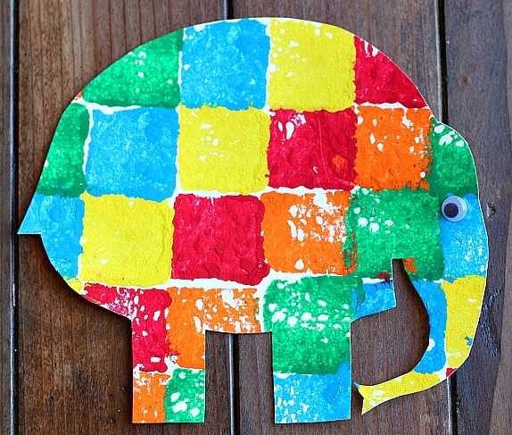  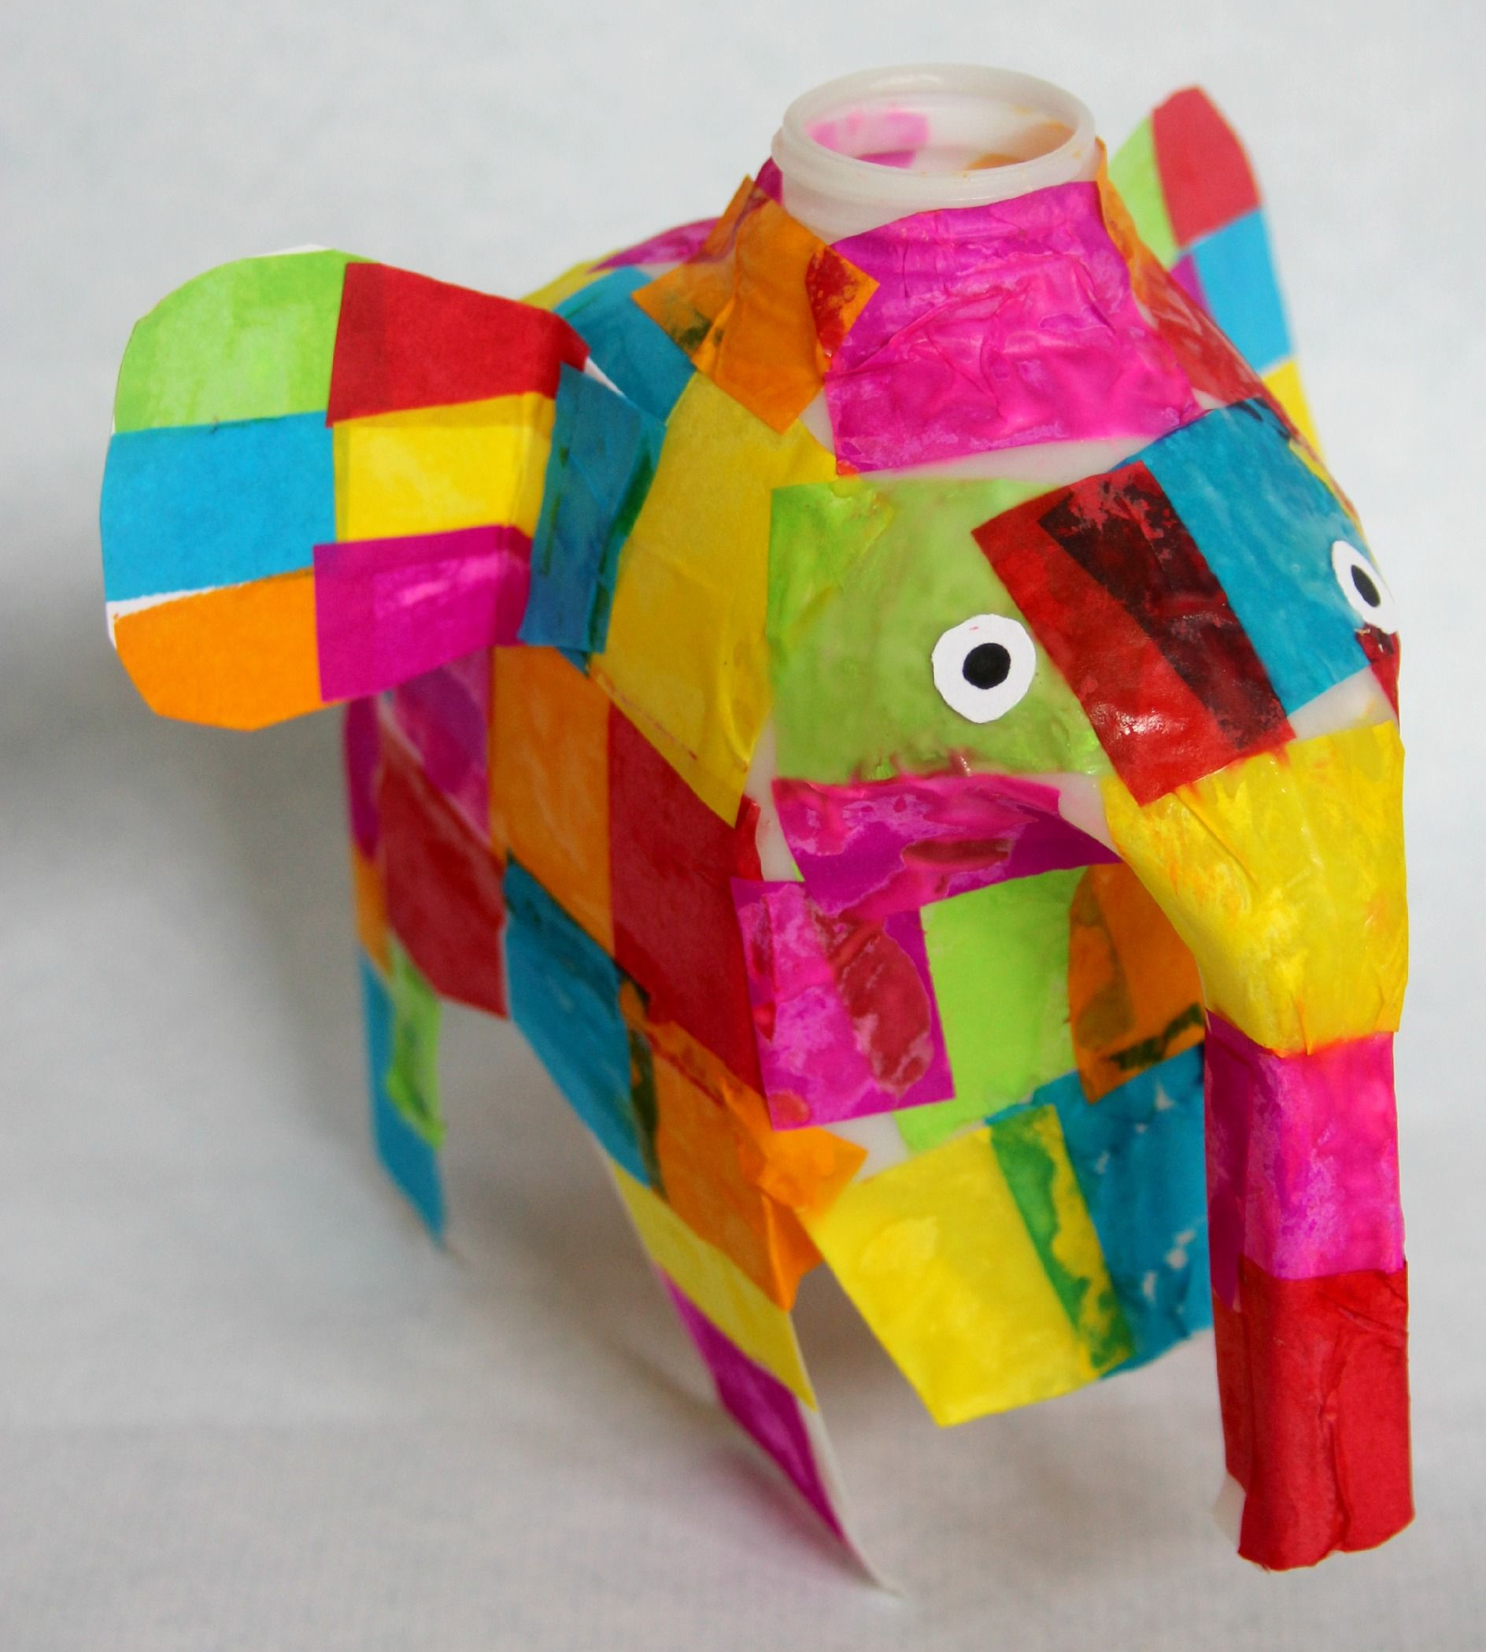  Can you create your own patchwork Elmer? You could use different materials (such as paint, pencils or tissue paper), different colours and different shapes!  Young Voices at Home -  Young Voices have launched a project to encourage teachers, parents and children to sing together. Simply click on the link to register for free https://www.youngvoices.co.uk/powerinme You will then be sent details of the 'Power in Me' song and all the learning materials you need. Learn the song and then join in with a special online broadcast on 2nd June! There are also details of a #PowerinMe Singing Challenge. This is a great opportunity to sing as a family and have some fun. Happy singing!
Communication and Language (C&L) | Role play one of the other elephants in the story. What is the story from their point of view? How do they feel about Elmer? What did they think when they saw he had turned himself grey?
Personal, Social and Emotional (PSED) |   Why was Elmer different and why did she decide to paint herself with berry juice to be the same as the other elephants? Talk to the children about how everyone is different and unique and that this is good!  What makes you different and special? Are you kind, or funny or helpful? Draw a picture of what makes you unique!
 | Good luck with this weeks home learning, please send photos on Tapestry so we can see how you are getting on and keep up the amazing job you are doing. From all the Early Years Team! We miss you all!

