St Edmund’s & St Joseph’s Catholic Primary Schools
Week commencing: 15th June 2020 Year group: Early Years
Below are some suggestions for learning that your child can do at home this week. We understand that the situation is unprecedented, however we do recommend that the children stay in touch with their learning using the ideas given below. You can help keep your child in contact with the school via the email link shown at the end of this message. Your child may want to share their achievements with their teacher by photographing or scanning it and sending it via email. A teacher will reply with a comment about the work shared.
Please email any completed activities/work to: homelearning@st-edmunds.suffolk.sch.uk
You can also send us your home learning via Tapestry, we love to see what you have been doing!

Subject/ Theme | Learning ideas and activities
Literacy | 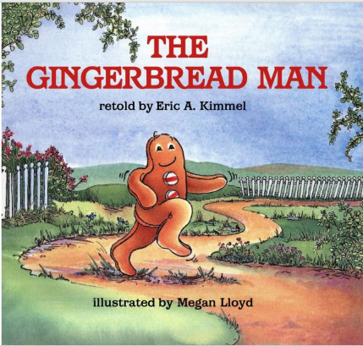  Please enjoy the story of The Gingerbread Man (see attached) or you may have your own version to read together.    Can you make some speech bubbles and write what the gingerbread man and the animals said in the story? (“Run, run, as fast as you can…”).
Maths | Make some gingerbread men. Weigh out the ingredients, count the spoonfuls with your child. See simple recipe attached. If you are struggling to find the ingredients, just make simple biscuits in a gingerbread man shape.
Understanding the world (UW) | Swimming Gingerbread Man Experiment. You will need: small gingerbread biscuits, bowls or cups, jug and water.  1. Pour some water into a bowl or cup.  2. Drop your gingerbread man gently into the filled container.  3. Talk about whether the gingerbread man floats or sinks.  4. Observe and talk about what happens to the gingerbread man over time.  5. watch as the gingerbread man slowly dissolves/disintegrates.  6. Repeat with different liquids (milk, tea, warm water). What happens in the differtent liquids?
Physical development (PD) | 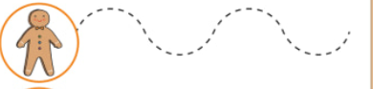  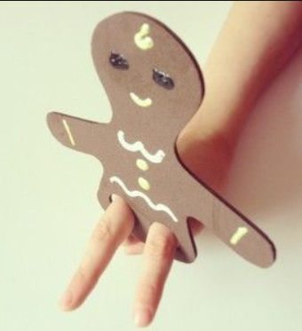  Make a gingerbread man out of cardboard and decorate. Cut out holes for fingers. Draw some different patterns, such as curvy, zig-zag lines for your gingerbread man to follow.
Art and design ( EAD) | Listen to The Gingerbread Man song https://www.youtube.com/watch?v=EoRrP12g6uk Clap hands, stamp feet, or play an instrument along to the music. Find the rhythm! Can you sing the chorus? Video it and put it on Tapestry so we can see it.
Communication and Language (C&L) | As you make the gingerbread men with your child, encourage them to listen carefully and follow the instructions that you give them.
Personal, Social and Emotional (PSED) | Talk to your child about stranger danger. Explain that the fox was pretending to the Gingerbread Man that he was going to help, when in fact he was not planning to help him at all. Talk about the importance of staying away from strangers. Encourage your child to think about what the Gingerbread Man should have done in that situation. Make a stranger danger poster using the fox and the gingerbread man.
 | Good luck with this weeks home learning, please send photos on Tapestry so we can see how you are getting on and keep up the amazing job you are doing. From all the Early Years Team! We miss you all!

Simple Gingerbread Man Recipe





