Handa’s Surprise
Investigation



Which fruit is heavier?
Circle the correct one
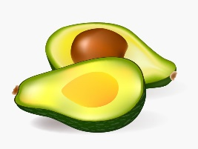Avocado | 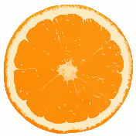Tangerine
Banana | 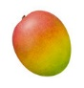Mango

Which fruit is lighter?
Circle the correct one

Pineapple | 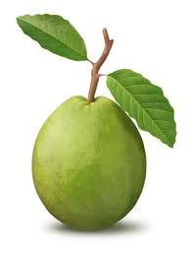Guava
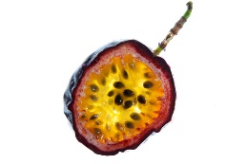Passionfruit | Mango
Next Steps: Can you find out which fruit is the heaviest of all?

