St Edmund’s & St Joseph’s Catholic Primary Schools
Week commencing: 22nd June 2020 Year group: Early Years
Below are some suggestions for learning that your child can do at home this week. We understand that the situation is unprecedented, however we do recommend that the children stay in touch with their learning using the ideas given below. You can help keep your child in contact with the school via the email link shown at the end of this message. Your child may want to share their achievements with their teacher by photographing or scanning it and sending it via email. A teacher will reply with a comment about the work shared.
Please email any completed activities/work to: homelearning@st-edmunds.suffolk.sch.uk
You can also send us your home learning via Tapestry, we love to see what you have been doing!

Subject/ Theme | Learning ideas and activities
Literacy | 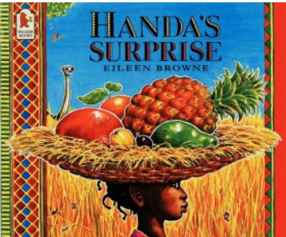  Please enjoy the story of Handa’s Surprise (see attached) or you may have your own version to read together. You can also watch the animated story here: https://youtu.be/XyIV_xYi0as  Draw your favourite fruit and write sentences to describe it.  Can you remember which animal took which fruit? Match the animals to the fruit, write a sentence for each animal: The monkey took the soft yellow banana.  Phonics practice, this game will help with blending Phase 3 sounds to read simple words.  https://www.phonicsplay.co.uk/resources/phase/3/pick-a-picture  Can you recognise all the Phase 3 sounds?
Maths | Weighing fruit and vegetables. Using the fruit and vegetables in your house, can you order them from the lightest to the heaviest? Which one was the heaviest? Lightest?  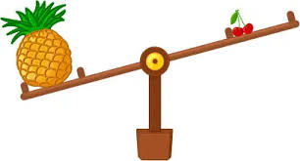
Understanding the world (UW) | 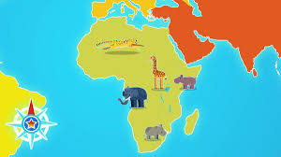  Handa’s Surpirse is set in the south west of Kenya. Can you find Kenya on a map? What continent is it in? Find out where the animals come from in the story. Can you make an animal from a different country using junk modelling?  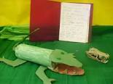  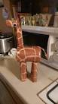
Physical development (PD) | Talk about healthy eating. Fruit and vegetable blind tasting. Have a selection of fruit and vegetables hidden in a bag for your child to taste. Use a blindfold or close eyes, get your child to select a fruit/vegetable, can they describe how it feels? Then taste the fruit/vegetable, what does it taste like? Use a word to describe its taste. Did you like it or dislike it?  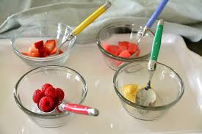
Art and design ( EAD) | 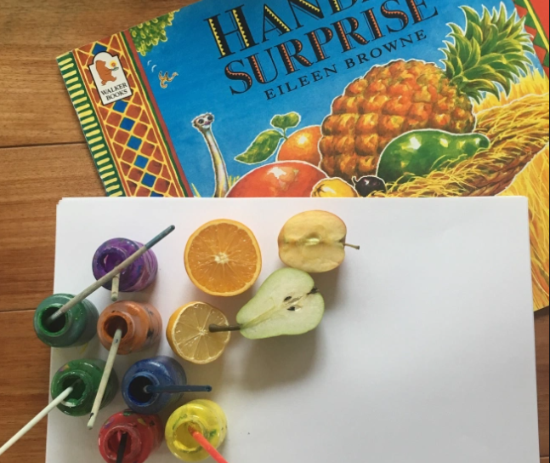  Use fruit and vegetables for printing. Cut the fruit in half, paint fruit and use to create a picture.  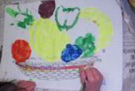  Or you could draw a picture of Handa’s basket and the fruit inside it.
Communication and Language (C&L) | 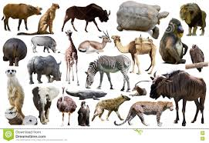  Talk about the animals in the story. Where do they live? How is it different to where you live? Would you see these animals walking down the street in the UK?
Personal, Social and Emotional (PSED) |   If you were going to collect some gifts for a friend, what would you give them? Draw a picture of your friend and their gift.
 | Good luck with this weeks home learning, please send photos on Tapestry so we can see how you are getting on and keep up the amazing job you are doing. From all the Early Years Team! We miss you all!

