St Edmund’s & St Joseph’s Catholic Primary Schools
Week commencing: 22nd June 2020 Class: Abraham
Learning Characteristic - Resourceful
Below are some suggestions for learning that your child can do at home this week. You can help keep your child in contact with the school via the email link shown at the end of this message. Your child may want to share their achievements with their teacher by photographing or scanning it and sending it via email. A teacher will reply with a comment about the work shared.
Please email any completed activities/work to: homelearning@st-edmunds.suffolk.sch.uk

Welcome to another week of Home Learning!!

We enjoyed an assembly with Mrs Kemble on Monday, Thursday and Friday – look out for when our next one is. It has been wonderful to see so many faces!

Keep an eye out for an email as I am trying to arrange an Abraham Class ‘Get Together’ soon.
Subject/ Theme | Learning ideas and activities
English | Spellings:  This week I have set you list 29  Year 3 you are learning homophones.  Year 4 you are learning the prefixes super-, anti- and auto.  Look at your spellings every day and ask a grown up to test you next Monday. I’d love to hear how you got on so don’t forget to share with me on Home Learning.  BBC BITESIZE - The new BBC Bitesize website offers lessons in English every day mainly focussing on grammar. It is also available on the red button on the BBC.  https://www.bbc.co.uk/bitesize/dailylessons  Reading:  Make sure you’re logging on to Accelerated Reader! We love to see your quizzes and word counts going up! Make sure you do at least one a week!! We have been watching your word counts increasing and some of you are almost millionaires! Keep going!  **REMEMBER** –  Accelerated Reader has opened up a free online library with access to hundreds of non-fiction books. The link below takes you directly to it. They can be read independently or there is an audio option. Books can be quizzed on in the normal way by putting in the title. DO CHECK the title before you read it as not all the books have quizzes yet!  https://readon.myon.co.uk/library/browse.html  Writing :  This week we will be learning about The Amazon Rainforest. I’d like you to put together an information sheet to tell me all about The Amazon Rainforest. You can include facts, a map, drawings, animals and lots more.  I have attached a information text checklist to remind you what you will need to include in your fact file.  Don’t forget to send these to our Home Learning so we can see all the hard work you have put into them.
Maths | White Rose Maths:  https://whiterosemaths.com/homelearning/year-4/  Year 4 Summer Term week 9.  https://whiterosemaths.com/homelearning/year-3/  Year 3 Summer Term week 9.  This gives you a Maths lesson for each day this week - it's manageable and you can check to see how you're doing. By following these lessons, it means your child maths learning is exactly where it should be as this is the scheme we follow in school.  Watch the PowerPoint presentation first and then have a go at the activities.  TT Rock Stars: Please do at least 2 sound checks and a gig. Then keep practising on garage and studio games, you need to get ready for another battle in the next few weeks!!  Mathletics : Continue to work through the activities we have set for you on Mathletics.
Thrive/PSHE Activities | This week you could have a go at:  - Making your own musical instrument  - Make your own paintbrushes  - Play Twister  - Create a school map  OR choose something else from the attached sheet.
Geography | This week we will be focusing on The Amazon Rainforest. There is a lesson powerpoint attached and an information presentation giving you lots of facts. Read through this and have a go at the activities I have suggested.  - Locate where the Amazon Rainforest is on a map  - Draw a diagram to show the different layers of the Rainforest  - Draw and label a Rainforest animal.  - Make a model of The Amazon Rainforest
Physical Education | This week I thought we could try something different.  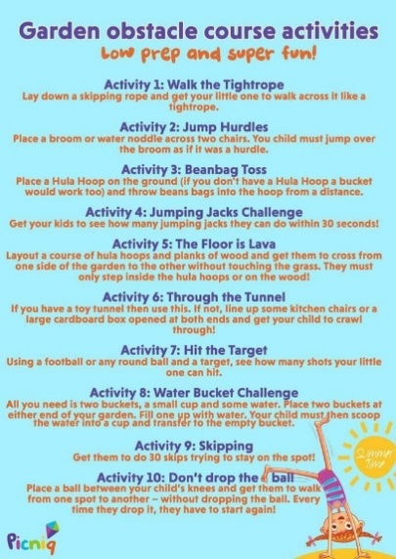  A copy of this is included in the attachments
Refugee Week | The Red Cross has released some resources for Refugee Week next week if you would like to use them.  The link is https://www.redcross.org.uk/get-involved/teaching-resources/refugee-week-imagine-a-kinder-world
French | French Origami activity.  Choisissez une vidéo. Suivez les instructions pour créer une forme en origami.  (Select a videoclip. Follow the instructions to create one of the origami shapes. Look up the key words you don't understand in the “useful word” list on the PDF document on your yeargroup page.)  Vidéo 1: la grenouille. https://www.youtube.com/watch?v=lSLAo9IMHR4  Vidéo 2. le serpent (harder). https://www.youtube.com/watch?v=iiBqwkPJ6qA  Vidéo 3. l’étoile Ninja (much harder!!) . https://www.youtube.com/watch?v=dBytyDqIuTk  Amusez-vous bien! Have fun!
30 days wild!  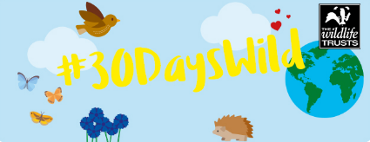 | June is the month the Wildlife Trust launches its ‘30 days wild!’ programme – it is an annual nature challenge.  The link is included below for you to have a look at. There are so many exiting things to do especially now we can start to safely explore a little further outside. Cloud watching, bare feet walking and lots more!  https://www.wildlifetrusts.org/  I have had some great pictures of some of your adventures – keep sending them in!!

