St Edmund’s & St Joseph’s Catholic Primary Schools
Week commencing: 29th June 2020 Year group: Early Years
Below are some suggestions for learning that your child can do at home this week. We understand that the situation is unprecedented, however we do recommend that the children stay in touch with their learning using the ideas given below. You can help keep your child in contact with the school via the email link shown at the end of this message. Your child may want to share their achievements with their teacher by photographing or scanning it and sending it via email. A teacher will reply with a comment about the work shared.
Please email any completed activities/work to: homelearning@st-edmunds.suffolk.sch.uk
You can also send us your home learning via Tapestry, we love to see what you have been doing!

Subject/ Theme | Learning ideas and activities
Literacy | 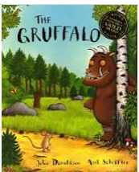  Please enjoy the story of The Gruffalo (see attached) or you may have your own version to read together. You can also watch the animated story here: https://www.bbc.co.uk/iplayer/episode/b00pk64x/the-gruffalo  Draw a picture of The Gruffalo and label it using descriptive words: knobbly knees, purple prickles, orange eyes.  Play the rhyming words: game: I Know a Word - "I know a word that rhymes with mouse. You live in it and it's called a ....". “I know a word that rhymes with snake. It’s full of water and is called a …”.
Maths | 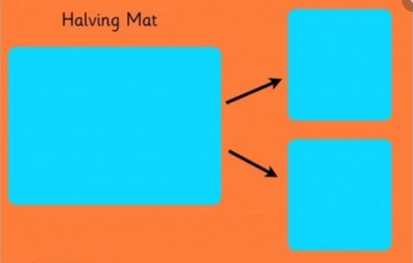  Mouse has a set of counters. He wants to give half to fox. Can your child help to make two piles of counters and say when they have the same number in each pile? Say ‘ half of 6 is…’. Repeat with different quantities.
Understanding the world (UW) | 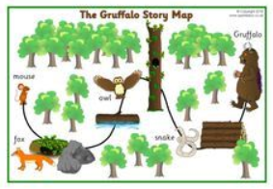  Draw a map of the route through the woodland that the gruffalo takes. Mark on the map the different animals and where they live. Use positional language to talk about where things are on the map. Use words such as under, over, next to, behind, in between.  Have a look at the Julia Donaldson website with some ICT activities: https://www.gruffalo.com/in-the-woods/?ReturnUrl=/activities/activities
Physical development (PD) | 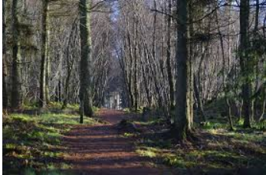  Go for a woodland walk and look at all the different plants, trees, can you spot any animals? Collect some natural resources along the way: leaves, sticks, pine cones. As you are walking stomp like the gruffalo, scurry like the mouse, slither like the snake.
Art and design ( EAD) | 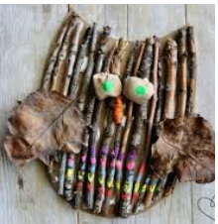  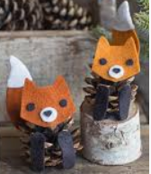  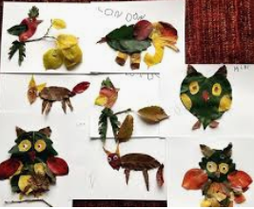  Children’s Art Week ‘The Natural World’. Use natural resources from your woodland walk to make an animal from the story. Use sticks, leaves, pine cones, anything you can find!
Communication and Language (C&L) | 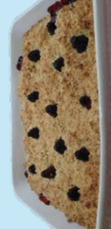  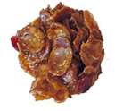  Make some gruffalo crumble/knobbly knees cake. Can you give your child instructions to follow when cooking? Listen and follow the instructions carefully. See recipes attached.
Personal, Social and Emotional (PSED) |   The mouse is very brave when he goes on his walk. At the end of the story the gruffalo is scared of the mouse. What makes you feel brave or what makes you feel scared? How do you make yourself feel better?
 | Good luck with this weeks home learning, please send photos on Tapestry so we can see how you are getting on and keep up the amazing job you are doing. From all the Early Years Team! We miss you all!

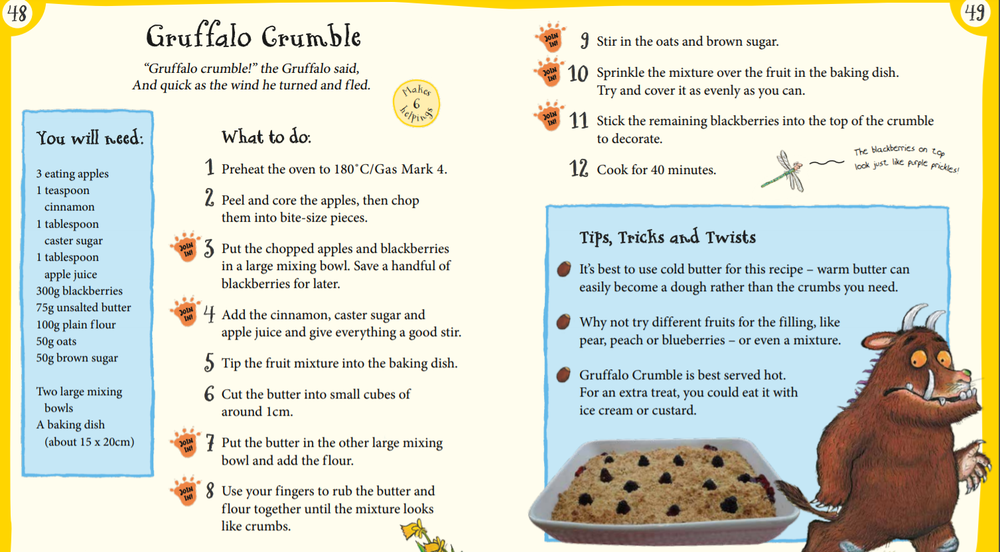
Knobbly Knees Gruffalo Cakes
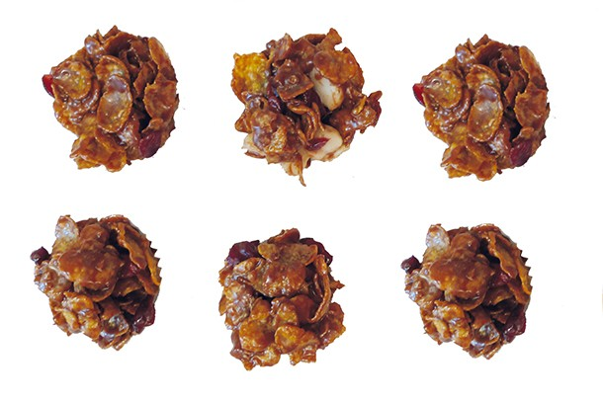
- 25g unsalted butter
- 100g chocolate
- 75g cornflakes
- 25g nuts
- 25g raisins
- 2 tbsp honey
You’ll also need…
- A small saucepan
- A big bowl
- 12 paper cases
- A muffin tray

Method

Break the chocolate into pieces with your hands and put in the small saucepan. 2. Add the butter and honey. 3. Melt over a low heat. Stir until everything is combined, and leave to cool. 4. Put the cornflakes, nuts and raisins in the big bowl. These are your dry ingredients. 5. Mix the dry ingredients together. 6. Pour the warm contents of the pan over the dry ingredients. 7. Mix everything together really well. It should be quite stiff. 8. Put 12 paper cases in the muffin tray. 9. Divide the mixture evenly between the paper cases. You can use a tablespoon to scoop it out of the bowl, and then scrape the mixture into the paper case using a teaspoon. 10. Put in the fridge for 2 hours to set.

