St Edmund’s & St Joseph’s Catholic Primary Schools
Week commencing: 6.7.20 Year group: One
Below are some suggestions for learning that your child can do at home this week. We understand that the situation is unprecedented, however we do recommend that the children stay in touch with their learning using the ideas given below. You can help keep your child in contact with the school via the email link shown at the end of this message. Your child may want to share their achievements with their teacher by photographing or scanning it and sending it via email. A teacher will reply with a comment about the work shared.
Please email any completed activities/work to: homelearning@st-edmunds.suffolk.sch.uk

Subject/ Theme | Learning ideas and activities
English  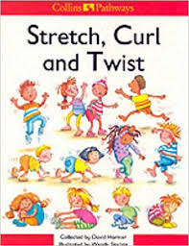  Thrive  RE | Join in and learn different action rhymes and poems using the document in this week’s home learning section.  Add your own actions and learn these off my heart so you can perform some of these to people at home.  Maybe you could make up your own poems or action rhymes. You could write these down or make recordings of these – we would love to see them!  Phonics/Spellings - over the next two weeks focus on the reading and spelling of high frequency words (document is in the home learning section for this week). Aim to read all the Year One words by sight and to spell as many of them as possible. Use the spellings ideas to help you with this. Post-it's are great to help with the reading of these words. Try putting words on doors around the house that you have to read before you go into rooms. You could write each word twice and have a game of ‘Snap!’ or make your own bingo game!  Scholastic Online Reading- please log on and read a book using your Reading Pro login details sent home via email last half term. Don’t forget to complete your quiz at the end too!  Spelling Shed focus – (St Joes only) 10 mins practise each day We have a phase 5 focus each week plus revision of phase 4 and year 1 tricky words  Handwriting- It has been lovely to see a number of parents sending in handwriting with cursive style to home learning. Please continue to use the handwriting sheets that were attached on 29/6 and the additional ones that are attached for this week.  Use the ‘Thrive’ resources for ideas of activities to do with your family.  RE – The Parable of the Lost Coin. Read the Bible story with an adult and then see if you can retell it using the pictures. Can you spot similarities to the story of ‘The Lost Sheep?’ Why do you think Jesus told this story?
Maths | Division - Have a look at the division powerpoint and talk about all the words that mean the same as divide e.g. share equally. Practise sharing raisins, lego bricks, buttons etc. equally between 2 people and then 3 or 4. Remember when you share out a quantity, you can draw circles for the number of groups you are making and say, ’one for you, one for you.....’ or ‘one each, two each....’ There are two challenges attached, where you can practise sharing out and also practise reading the division sign in number sentences.  Children are also able to follow the BBC Bitesize Daily Maths lessons (Monday to Friday) on the website. ( Further work on halves and quarters with challenge of week for Friday)  Link below:  https://www.bbc.co.uk/bitesize/tags/zjpqqp3/year-1-and-p2-lessons/1  Don’t forget to use Mathletics, Times Table Rockstars and Numbots to practise your Maths and to improve your fluency and knowledge of times tables.
Science, History or Geography | Science – Have a go at ‘charming’ worms in your garden or local park? Follow the link to get ideas from Lucy at Suffolk Wildlife Trust https://www.youtube.com/watch?v=vVOcT_PUS_Q  History – John Constable is a famous artist who painted landscapes in the Suffolk area. There are three documents to look at to find out about him, to look at examples of the pictures he painted and all about Willy Lott’s Cottage, which can be seen in some of his paintings, especially ‘The Hay Wain’. Can you draw pictures to show the differences between how people lived, cooked and washed clothes between now and then? Maybe use a photo or view that you can see to paint your own landscape painting.
Physical Education         | Tennis: We should be in 2nd week of Wimbledon this week. Here is a link to some fun tennis activities for home, many of which are suitable for children aged 4-7 years.  https://www.lta.org.uk/tennis-at-home  Disney 10 Minute Shakeups  Description: 10-minute activities based on Disney films that count towards a child’s 60 active minutes per day  Website: https://www.nhs.uk/10-minute-shake-up/shake-ups  DANCES to try this week!  WE'RE GOING ON A BEAR HUNT  https://vimeo.com/307592608  RAK SU - DIMELO  https://vimeo.com/283470830  GREATEST SHOWMAN - THIS IS ME  https://vimeo.com/364587099  Park Run Daily Challenges  Description: Each morning a new challenge for the day is posted on the Park Run YouTube channel. All challenges can be done around the house or in the garden. Every Sunday morning there is a special junior parkrun warm-up that the whole family can try in the living room or garden!
  Arty crafty ideas  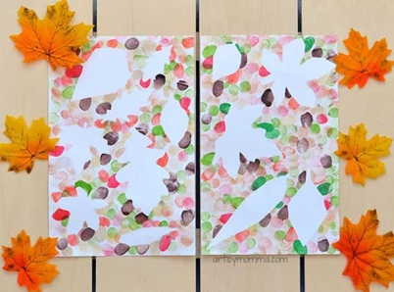 | Art – When you are outside you could collect leaves and make some pictures using them. Some ideas for inspiration are included in a powerpoint.  If you have paint you could use a brush to put paint onto the back of a leaf and then print with it. Using more than one colour on a leaf is very effective. https://www.youtube.com/watch?v=oKbisLkqgVY  You could also work in relief – so paint or colour around the leaf, take the leaf away and the blank part is in the shape of a leaf. (You could do this using finger paints or chalk too as on the left here.)  Leaf rubbing is really fun too. Put the leaf under some paper, vein side up. Use a wax crayon on it’s side and rub across the where you can feel the leaf is.You have to press fairly hard.  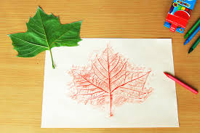  You can also thread leaves together or sew onto them. See this link for making leaf hearts. https://www.youtube.com/watch?v=3gBylcWODfQ

