St Edmund’s & St Joseph’s Catholic Primary Schools
Week commencing: 6th July 2020 Year group: Early Years
Below are some suggestions for learning that your child can do at home this week. We understand that the situation is unprecedented, however we do recommend that the children stay in touch with their learning using the ideas given below. You can help keep your child in contact with the school via the email link shown at the end of this message. Your child may want to share their achievements with their teacher by photographing or scanning it and sending it via email. A teacher will reply with a comment about the work shared.
Please email any completed activities/work to: homelearning@st-edmunds.suffolk.sch.uk
You can also send us your home learning via Tapestry, we love to see what you have been doing!

Subject/ Theme | Learning ideas and activities
Literacy | 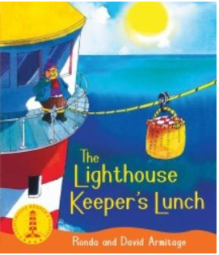  Please enjoy the story of The Lighthouse Keeper’s Lunch (see attached) or you may have your own version to read together. You can also listen to the story here: https://www.youtube.com/watch?v=46wCRq50Wwg  Make a list of all the items in your house and garden that are a light source eg. Sun, candle, lamps, torch, computer. Mr Grinling has a very busy day. Write down one thing he does in the morning, one thing he does during the day and then one thing he does at night-time.
Maths | 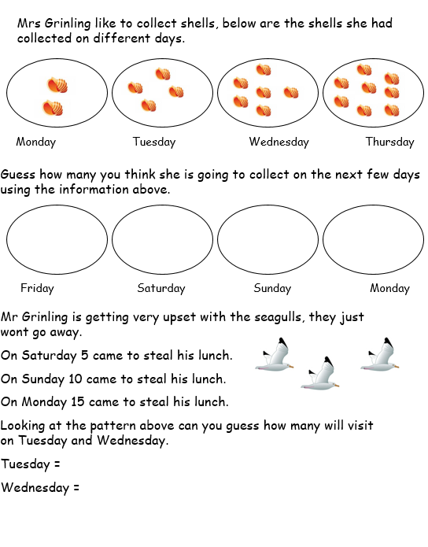  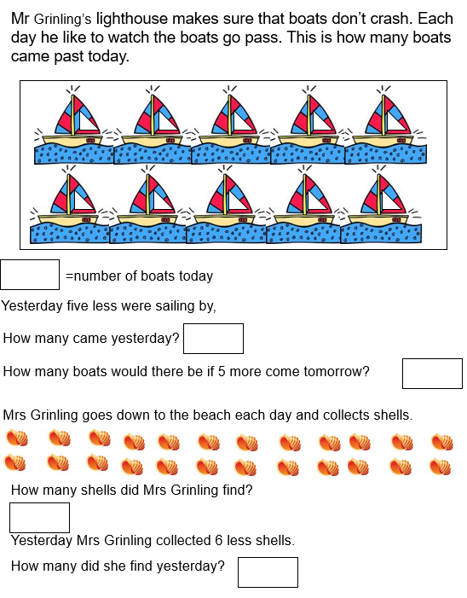  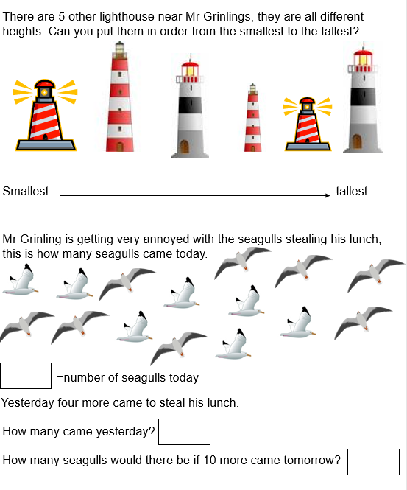  Can you complete the answers to the problems on a piece of paper or on a whiteboard? (maths problem sheets attached).
Understanding the world (UW) | 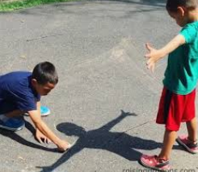  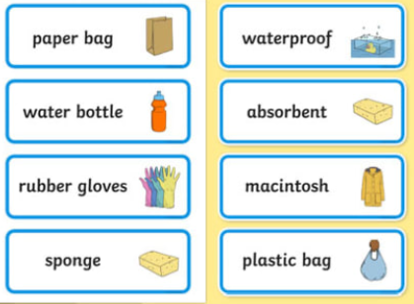  Plan and carry out an investigation to find out the strength of different materials. Which materials would be waterproof and seagull proof? Which would be best to protect the lighthouse keeper's lunch?  If it’s sunny go outside and mark a spot in your garden to stand on at different times throughout the day, and draw your shadow. Talk about what happens.
Physical development (PD) | 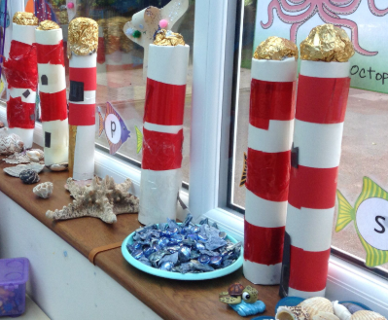  Use junk modelling to create your own lighthouse.  Cosmic Kids Yoga: https://www.youtube.com/watch?v=GDwyVonx35Q
Art and design ( EAD) | Mr Grinling has to go to the lighthouse come rain or shine. Can you draw the clothes he would need to take with him on a rainy and a sunny day?
Communication and Language (C&L) | 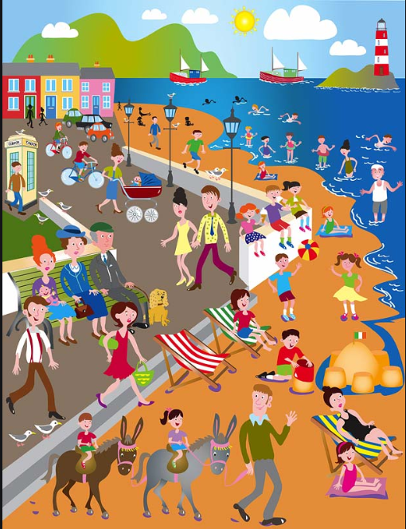  Can you talk about a time when you visited the seaside, what did you do? What did you see?  Or look at this picture, can you talk about what is happening in the picture of the seaside?
Personal, Social and Emotional (PSED) |   Hamish the cat felt scared when he had to go in the basket. What could you do to make Hamish feel better?
 | Good luck with this weeks home learning, please send photos on Tapestry so we can see how you are getting on and keep up the amazing job you are doing. From all the Early Years Team! We miss you all!

Maths Activities

