Fractions Problems
- You are given money to buy an Easter egg. It costs half your money. How much does it cost?
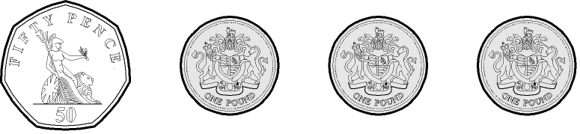
- What is three quarters of 20 mini eggs?

- Amy has 48 eggs in her basket. One quarter of them are white chocolate, one quarter of them are dark chocolate and half of them are milk chocolate.
How many white chocolate eggs does she have?
How many dark chocolate eggs does she have?
How many milk chocolate eggs does she have?
- A shop sold ¾ of their cream eggs on Tuesday, which was 12. How many cream eggs did they have in total before selling the 12 cream eggs?

- Church made 214 palm crosses. They gave ½ to children and ½ to adults. How many palm crosses were given to children?

- Katie made a huge Easter egg hunt with 160 mini eggs. Charlie’s team found ¼ of them. How many did he find?

- One quarter of Mary’s Easter eggs were malteaser eggs. She had 2 malteaser eggs. How many eggs did she have altogether?

