Monday 11^{h} May 2020
Hello everyone,
I hope you and your families are keeping well and have been enjoying the beautiful weather.
It was lovely to see lots of your home learning from last week, particularly using the VE related resources that were on the website. The sun shone for us on Friday so I hope lots of you were able to spend some time in the garden maybe with a picnic or a BBQ.
In the Martin house, we enjoyed playing lots of games outside and made red, white and blue bunting to hang in the window. We also decorated stones and pebbles in red, white and blue paint and had a delicious picnic with homemade scones. I am sure many of you did the same and made special memories with your family.
Although it is important that you concentrate hard on your school work when you are learning at home it is still very important to spend lots of quality time with your family. My youngest little boy loves elephants, so we decided to snuggle up as a family, have some popcorn and watch the film Dumbo together. I remembered watching it with my family when I was a little girl so it was lovely to watch it again with my own children. We enjoyed the story so much that the following day we read the story and did some writing about Dumbo and made 3D models using milk cartons. My children thought that you would like to see them so there is a picture below. I have also added some pictures of our VE day celebrations.
Take care everybody. Missing you all lots. Love from Mrs Martin
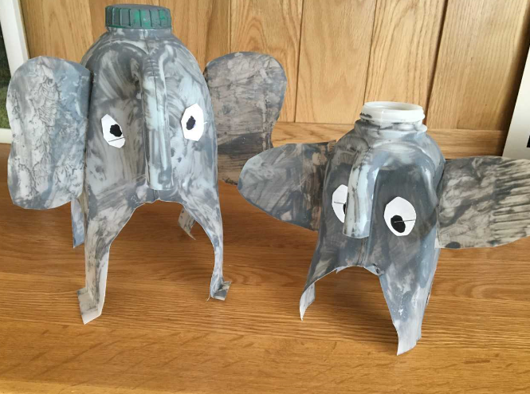
(VE day photos on the next page!)

Dumbo 3D models.
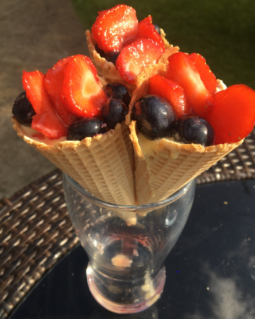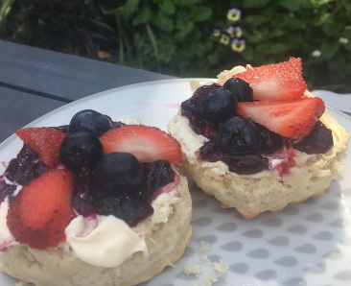
Vanilla ice cream with strawberries, blueberries and strawberry sauce.
Fruit scones with cream, strawberries and blueberries (red, white and blue)
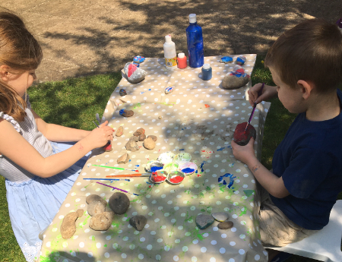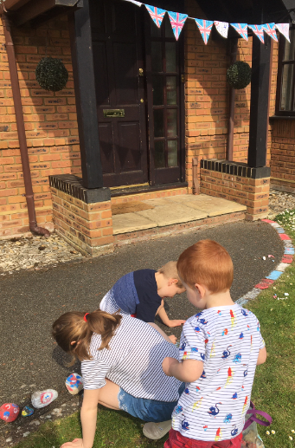
Pebble painting and decorating the garden. Can you spot my two year old’s bunting piece?
