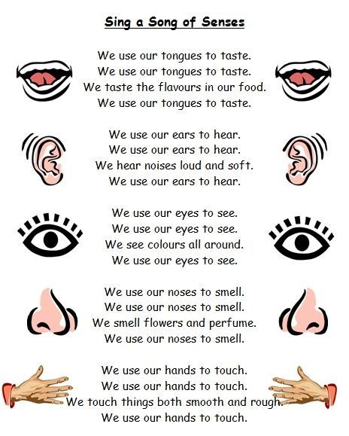

(Sing to the tune of ‘The Farmer’s in the Dell’)

