A flower has 5 petals.  How many petals have 3 flowers got? __  ___ x ___ = ____ | A flower has 5 petals.  How many petals has 5 flowers got? ___  ___ x ___ = ____
There are 7 days in one week.  How many days are there in 2 weeks? __  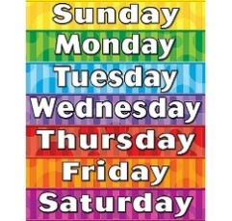  ___ x ___ = ____ | There are 7 days in one week.  How many days are there in 3 weeks? __  ___ x ___ = ____
There are 8 sweets in a packet.  How many sweets will be in 2 packets? _  ______________________________ | There are 8 sweets in a packet.  How many sweets will be in 3 packets? _  ______________________________
There are 4 packets of crayons and 10 in each pack.  How many crayons altogether? ___  ______________________________ | There are 6 packets of crayons and 10 in each pack.  How many crayons altogether? ___  ______________________________

One boy has 2 legs.  How many legs will 6 boys have? ___  ______________________________ | One boy has 2 legs.  How many legs will 8 boys have? ___  _______________________________
A pentagon has 5 sides.  How many will 2 pentagons have? _____  ______________________________ | A pentagon has 5 sides.  How many will 10 pentagons have? _____  ______________________________

Which has more?
4 bags of sweets with 5 in each or 3 bags of sweets with 10 in each?
______________________________________________________
Draw your reasoning and write multiplication calculations.

