Monday 13th July 2020
Hello everyone,
It was great to see so many of you at the transition session last week. How lovely it was to spend some time together chatting about what you had been doing at home. It was also lovely to spend some time with Mrs Jackson and Mr Payne as you move up to year 3.
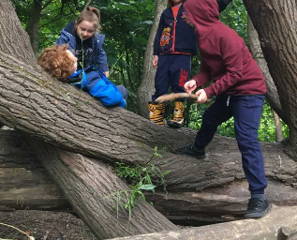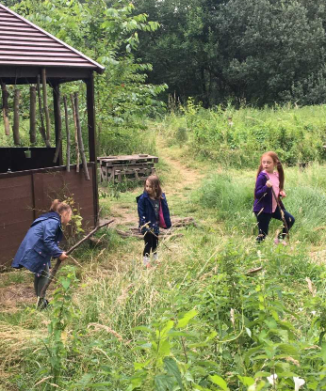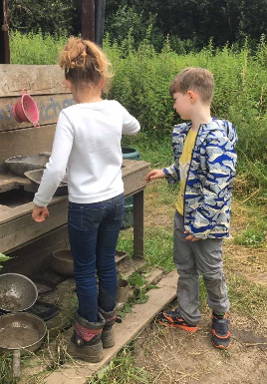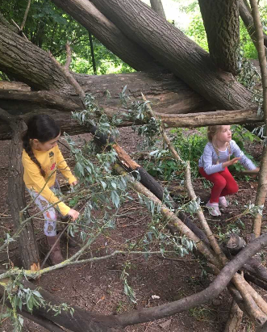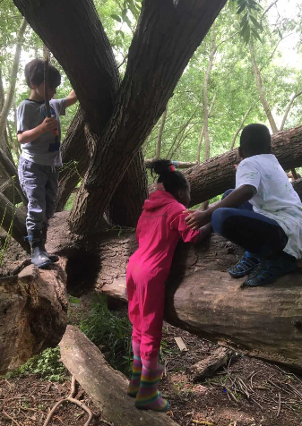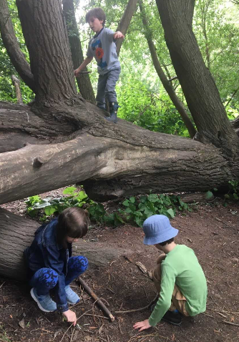

I can’t quite believe this will be my last letter to you. It has been a very strange year having not spent so long together in school. I just want to take this opportunity to say how immensely proud I am of each and every one of you for continuing to learn together in God’s love and your determination to keep on going. I have loved teaching you.
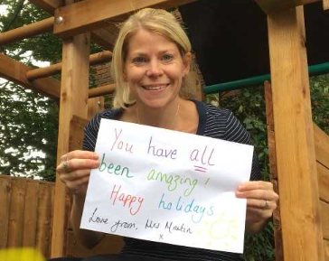

As I write this, I have a few tears in my eyes as I reflect on the past few months but thank you for staying so positive with your home learning and to all the grown-ups for the support they have provided.

Take care everyone. I am going to miss being your teacher but I know you are going to love being in year 3 and I will still be able to see you all.

Have a wonderful holiday.
Love from Mrs Martin

